**CYBER ATTACKS DETECTION USING MACHINE LEARNING**

**ABSTRACT**

In an era where digital interactions dominate our daily lives, safeguarding digital systems from cyber threats has become paramount. The project, "Cyber Attacks Detection Using Machine Learning," addresses this critical need by harnessing the power of machine learning algorithms to identify and classify cyber attacks. Leveraging a robust dataset sourced from Kaggle, encompassing approximately 500,000 records, the project focuses on intrusion detection.

Multiple machine learning algorithms, including Gaussian Naive Bayes, Decision Tree, Logistic Regression, Gradient Classifier, and the formidable Random Forest, are employed to analyze the dataset comprehensively. Among these, Random Forest emerges as the standout performer, boasting the highest accuracy in detecting cyber attacks. The dataset comprises various attack types, including Denial of Service (DoS), normal, probe, R2L (Remote-to-Local), and U2R (User-to-Root), enabling the system to classify and differentiate between these threats effectively.

The project manifests as a user-friendly web application, where users can input relevant parameters to predict the type of cyber attack. This intuitive platform offers a practical solution for organizations and individuals seeking to enhance their cybersecurity measures. By proactively identifying and classifying cyber threats, the project contributes significantly to bolstering digital security and fortifying against the ever-evolving landscape of cyberattacks.

**OBJECTIVE**

The project aims to develop a machine learning-based system for precise cyber attack detection, including DoS, probe, R2L, U2R, and normal traffic. It emphasizes the use of Random Forest as the top-performing algorithm. The user-friendly web application interface enhances cybersecurity measures by allowing users to input parameters and receive accurate attack type predictions.

**SCOPE**

The scope of the "Cyber Attacks Detection Using Machine Learning" project is to create a comprehensive solution for cyber threat detection and classification. It encompasses the development of machine learning models capable of identifying DoS, probe, R2L, U2R, and normal traffic, with a focus on Random Forest's high accuracy. The project's web application interface extends its reach to users seeking efficient cybersecurity enhancements, providing a practical tool for organizations and individuals alike.

**INTRODUCTION**

In the rapidly evolving digital landscape, cybersecurity has become paramount to safeguarding critical data and systems from an ever-increasing array of cyber threats. The "Cyber Attacks Detection Using Machine Learning" project introduces a cutting-edge solution designed to revolutionize the way cyber attacks are identified and classified. Traditional intrusion detection systems often rely on predefined rules and patterns, struggling to adapt to new and sophisticated attack techniques. This project seeks to bridge this gap by harnessing the power of machine learning, particularly the highly accurate Random Forest algorithm, to provide precise and adaptive cyber attack detection and classification. By focusing on diverse attack types, including Denial of Service (DoS), probe, Remote-to-Local (R2L), User-to-Root (U2R), and normal network traffic, the system aims to offer granular insights into the nature of threats. Additionally, the project includes the development of a user-friendly web application interface that enables real-time predictions of cyber attack types, empowering organizations and individuals to bolster their cybersecurity measures. This project represents a significant leap forward in enhancing digital security and resilience against an ever-changing cyber threat landscape.

**EXISTING SYTEM**

The existing cybersecurity landscape relies predominantly on rule-based and signature-based intrusion detection systems that struggle to adapt to evolving cyber threats. These conventional systems often lack the agility and accuracy required to effectively identify diverse cyber attacks, including Denial of Service (DoS), probe, Remote-to-Local (R2L), User-to-Root (U2R), and normal network traffic. Moreover, their dependency on predefined rules limits their capacity to respond to emerging threats, leaving vulnerabilities unaddressed. This underscores the need for a more sophisticated approach, such as machine learning-based intrusion detection, to enhance cybersecurity and proactively identify and classify cyber threats with higher precision and adaptability.

**DISADVANTAGES OF EXISTING SYTEM**

1. Limited Adaptability: Conventional rule-based and signature-based intrusion detection systems struggle to adapt to new and evolving cyber threats. They rely on predefined rules and patterns, making them less effective at identifying novel attack methods.
2. False Positives: These systems often generate a high number of false positive alerts, overwhelming security teams with irrelevant notifications and leading to alert fatigue.
3. Vulnerability to Zero-Day Attacks: Signature-based systems are particularly vulnerable to zero-day attacks, as they cannot detect threats that do not match known attack patterns.
4. Lack of Granularity: Existing systems may lack the granularity to differentiate between various types of cyber attacks, making it challenging to prioritize responses.
5. Maintenance Overhead: Maintaining and updating rule-based systems with new signatures and rules can be time-consuming and resource-intensive.
6. Inefficiency in Large Networks: In large and complex network environments, these systems may struggle to scale effectively and provide comprehensive coverage.
7. Limited Predictive Capability: Traditional systems focus on detecting ongoing attacks but lack predictive capabilities to anticipate and prevent threats.
8. Reduced Accuracy: The reliance on static rules and patterns can lead to reduced accuracy in detecting sophisticated and polymorphic attacks.

**PROPOSED SYSTEM**

The proposed system represents a significant advancement in cybersecurity by harnessing the power of machine learning for precise and adaptive cyber attack detection and classification. Unlike the limitations of existing systems, the proposed approach employs sophisticated machine learning algorithms, with a particular focus on the highly accurate Random Forest model, to identify and categorize diverse cyber threats, including Denial of Service (DoS), probe, Remote-to-Local (R2L), User-to-Root (U2R), and normal network traffic. The system will provide a user-friendly web application interface, enabling users to input relevant parameters and obtain real-time predictions regarding the type of cyber attack. By leveraging machine learning's adaptability and accuracy, the proposed system aims to enhance cybersecurity measures significantly, proactively addressing evolving threats and reducing false positives, ultimately contributing to a more secure digital environment.

**ADVANTAGES OF PROPOSED SYSTEM**

1. Enhanced Accuracy: By utilizing machine learning algorithms, including the high-performing Random Forest model, the system achieves superior accuracy in identifying and classifying cyber attacks, reducing false positives and enhancing threat detection.
2. Adaptability: Unlike rule-based systems, the proposed approach can adapt to emerging cyber threats and novel attack techniques, ensuring ongoing effectiveness in a dynamic threat landscape.
3. Comprehensive Classification: The system can categorize diverse cyber attacks, including Denial of Service (DoS), probe, Remote-to-Local (R2L), User-to-Root (U2R), and normal traffic, providing granular insights into the nature of threats.
4. Real-time Predictions: Users benefit from a user-friendly web application interface that enables real-time predictions of cyber attack types, facilitating rapid response and mitigation.
5. Reduced Alert Fatigue: The system's ability to reduce false positives and generate more accurate alerts minimizes alert fatigue among security personnel, allowing them to focus on genuine threats.
6. Proactive Security: With its adaptive nature, the system proactively identifies and addresses potential threats, enhancing overall cybersecurity posture.
7. Cost-Efficiency: The system's accuracy and adaptability can lead to cost savings by reducing the impact of cyber attacks and optimizing resource allocation.
8. User-Friendly Interface: The web application interface makes it accessible to a wide range of users, from organizations to individuals, simplifying the process of enhancing cybersecurity measures.

**LITERATURE SURVEY**

**TITLE:** "A Deep Learning Ensemble for Network Anomaly and Cyber-Attack Detection"

**ABSTRACT:** Currently, expert systems and applied machine learning algorithms are widely used to automate network intrusion detection. In critical infrastructure applications of communication technologies, the interaction among various industrial control systems and the Internet environment intrinsic to the IoT technology makes them susceptible to cyber-attacks. Given the existence of the enormous network traffic in critical Cyber-Physical Systems (CPSs), traditional methods of machine learning implemented in network anomaly detection are inefficient. Therefore, recently developed machine learning techniques, with the emphasis on deep learning, are finding their successful implementations in the detection and classification of anomalies at both the network and host levels. This paper presents an ensemble method that leverages deep models such as the Deep Neural Network (DNN) and Long Short-Term Memory (LSTM) and a meta-classifier (i.e., logistic regression) following the principle of stacked generalization. To enhance the capabilities of the proposed approach, the method utilizes a two-step process for the apprehension of network anomalies. In the first stage, data pre-processing, a Deep Sparse AutoEncoder (DSAE) is employed for the feature engineering problem. In the second phase, a stacking ensemble learning approach is utilized for classification. The efficiency of the method disclosed in this work is tested on heterogeneous datasets, including data gathered in the IoT environment, namely IoT-23, LITNET-2020, and NetML-2020. The results of the evaluation of the proposed approach are discussed. Statistical significance is tested and compared to the state-of-the-art approaches in network anomaly detection.

**TITLE:** "A survey of IoT malware and detection methods based on static features"

**ABSTRACT:** Due to a lack of security design as well as the specific characteristics of [IoT](https://www.sciencedirect.com/topics/engineering/internet-of-things) devices such as the heterogeneity of processor architecture, IoT [malware](https://www.sciencedirect.com/topics/engineering/malware) detection has to deal with very unique challenges, especially on detecting cross-architecture IoT malware. Therefore, the IoT malware detection domain is the focus of research by the security community in recent years. There are many studies taking advantage of well-known dynamic or [static analysis](https://www.sciencedirect.com/topics/computer-science/static-program-analysis) for detecting IoT malware; however, static-based methods are more effective when addressing the multi-architecture issue. In this paper, we give a thorough survey of static IoT malware detection. We first introduce the definition, evolution and security threats of IoT malware. Then, we summarize, compare and analyze existing IoT malware detection methods proposed in recent years. Finally, we carry out exactly the methods of existing studies based on the same IoT malware dataset and an experimental configuration to evaluate objectively and increasing the reliability of these studies in detecting IoT malware.

**TITLE:** "Research on Artificial Intelligence Enhancing Internet of Things Security: A Survey"

**ABSTRACT:** Through three development routes of authentication, communication, and computing, the Internet of Things (IoT) has become a variety of innovative integrated solutions for specific applications. However, due to the openness, extensiveness and resource constraints of IoT, each layer of the three-tier IoT architecture suffers from a variety of security threats. In this work, we systematically review the particularity and complexity of IoT security protection, and then find that Artificial Intelligence (AI) methods such as Machine Learning (ML) and Deep Learning (DL) can provide new powerful capabilities to meet the security requirements of IoT. We analyze the technical feasibility of AI in solving IoT security problems and summarize a general process of AI solutions for IoT security. For four serious IoT security threats: device authentication, Denial of Service (DoS) and Distributed Denial of Service (DDoS) attacks defense, intrusion detection and malware detection, we summarize representative AI solutions and compare the different algorithms and technologies used by various solutions. It should be noted that although AI provides many new capabilities for the security protection of IoT, it also brings new potential challenges and possible negative effects to IoT in terms of data, algorithm and architecture. In the future, how to solve these challenges can serve as potential research directions.

**TITLE:** "Security Threats and Artificial Intelligence Based Countermeasures for Internet of Things Networks: A Comprehensive Survey",

**ABSTRACT:** The Internet of Things (IoT) has emerged as a technology capable of connecting heterogeneous nodes/objects, such as people, devices, infrastructure, and makes our daily lives simpler, safer, and fruitful. Being part of a large network of heterogeneous devices, these nodes are typically resource-constrained and became the weakest link to the cyber attacker. Classical encryption techniques have been employed to ensure the data security of the IoT network. However, high-level encryption techniques cannot be employed in IoT devices due to the limitation of resources. In addition, node security is still a challenge for network engineers. Thus, we need to explore a complete solution for IoT networks that can ensure nodes and data security. The rule-based approaches and shallow and deep machine learning algorithms- branches of Artificial Intelligence (AI)- can be employed as countermeasures along with the existing network security protocols. This paper presented a comprehensive layer-wise survey on IoT security threats, and the AI-based security models to impede security threats. Finally, open challenges and future research directions are addressed for the safeguard of the IoT network.

**TITLE:** "The evolution of IoT Malwares, from 2008 to 2019: Survey, taxonomy, process simulator and perspectives",

**ABSTRACT:** The past decade has seen a rapidly growing interest in IoT-connected devices. But as is usually the case with computer systems and networks, malicious individuals soon realized that these objects could be exploited for criminal purposes. The problem is particularly salient since the firmware used in many Internet connected devices was developed without taking into consideration the expertise and best security practices gained over the past several years by programmers in other areas. Consequently, multiple attacks on IoT devices took place over the last decade, culminating in the largest ever recorded DDoS attack, the Mirai botnet, which took advantage of weaknesses in the security of the IoT. In this survey, we seek to shed light on the evolution of the IoT malware. We compare the characteristic features of 28 of the most widespread IoT malware programs of the last decade and propose a novel methodology for classifying malware based on its behavioral features. Our study also highlights the common practice of feature reuse across multiple malware programs.

**METHODOLOGY**

1. **Data Collection:** Acquiring a comprehensive dataset from Kaggle, containing approximately 500,000 records of network traffic, including both normal and various types of cyber attacks, such as DoS, probe, R2L, and U2R.
2. **Data Preprocessing:** Cleaning and preparing the dataset by handling missing values, standardizing features, and ensuring data consistency to facilitate accurate machine learning model training.
3. **Feature Selection:** Identifying and selecting relevant features that have the most significant impact on cyber attack detection, using techniques like correlation analysis and feature importance ranking.
4. **Model Development:** Implementing multiple machine learning algorithms, including Gaussian Naive Bayes, Decision Tree, Random Forest, Logistic Regression, and Gradient Classifier, with a specific emphasis on the high-performing Random Forest model.
5. **Model Training:** Splitting the dataset into training and testing sets to train and evaluate the machine learning models' performance. Employing techniques like cross-validation and hyperparameter tuning to optimize model accuracy.
6. **Real-time Prediction:** Developing a user-friendly web application interface that allows users to input network traffic parameters and obtain real-time predictions regarding the type of cyber attack.
7. **Evaluation:** Assessing the models' performance using metrics like accuracy, precision, recall, and F1-score to ensure accurate and reliable cyber attack detection.
8. **Deployment:** Deploying the trained models and the web application interface to enable users, including organizations and individuals, to utilize the system for enhanced cybersecurity measures.

**FLOW CHART DIAGRAM**

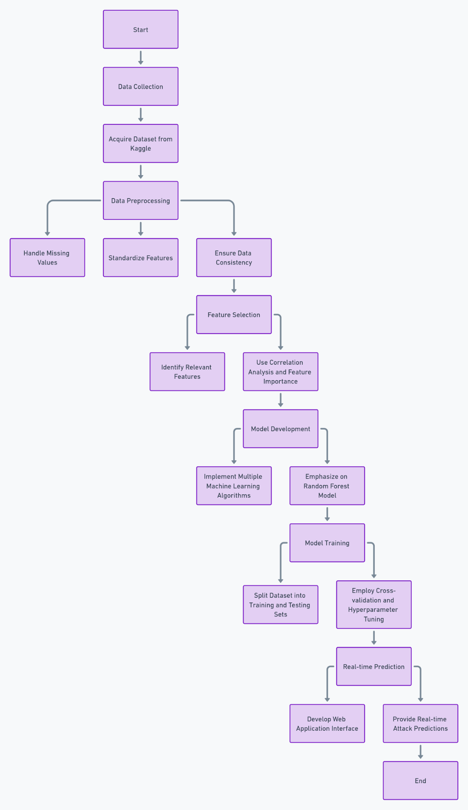

**SYSTEM REQUIREMENTS**

**HARDWARE REQUIREMENTS**

|  |  |  |
| --- | --- | --- |
| MINIMUM (Required for Execution) | | MY SYSTEM (Development) |
| System | Pentium IV 2.2 GHz | i3 Processor 5th Gen |
| Hard Disk | 20 Gb | 500 Gb |
| Ram | 1 Gb | 4 Gb |

**SOFTWARE REQUIREMENTS**

|  |  |
| --- | --- |
| Operating System | Windows 10/11 |
| Development Software | Python 3.10 |
| Programming Language | Python |
| Integrated Development Environment (IDE) | Visual Studio Code |
| Front End Technologies | HTML5, CSS3, Java Script |
| Back End Technologies or Framework | Django |
| Database Language | SQL |
| Database (RDBMS) | MySQL |
| Database Software | WAMP or XAMPP Server |
| Web Server or Deployment Server | Django Application Development Server |
| Design/Modelling | Rational Rose |

**CONCLUSION**

In conclusion, the "Cyber Attacks Detection Using Machine Learning" project represents a significant advancement in the field of cybersecurity. By leveraging machine learning algorithms, with a particular focus on the highly accurate Random Forest model, the project offers a precise and adaptive solution for cyber attack detection and classification. Traditional intrusion detection systems often struggle to keep pace with evolving attack techniques, leading to vulnerabilities and false positives. However, this project addresses these shortcomings by providing a proactive and granular approach to identifying diverse cyber threats, including Denial of Service (DoS), probe, Remote-to-Local (R2L), User-to-Root (U2R), and normal network traffic.

The user-friendly web application interface adds another layer of accessibility, enabling organizations and individuals to benefit from real-time predictions of cyber attack types. By reducing false positives and alert fatigue, the system enhances overall cybersecurity measures, making it a valuable asset in the digital age.

This project exemplifies the potential of machine learning in bolstering cybersecurity and offers a practical tool for defending against the ever-evolving cyber threat landscape. It contributes to a safer and more resilient digital environment, ultimately protecting critical data and systems from malicious attacks.